Ideation Phase
Empathize & Discover

Date | 19 FEBRUARY 2026
Team ID | LTVIP2026TMIDS43588
Project Name | DocSpot: Seamless Appointment Booking for Health
Maximum Marks | 4 Marks

Empathy Map Canvas:
An Empathy Map Canvas is a visual tool used to understand users better. It helps teams see the product or service through the user's eyes by exploring:
- What the user thinks
- What the user feels
- What the user says
- What the user does
This approach uncovers key insights about the user's experiences, motivations, and pain points.

Why Use an Empathy Map?
- To gain deeper user understanding beyond just facts or numbers.
- To identify real needs, frustrations, and goals of the user.
- To encourage team empathy—the core of user-centered design.

How It Supports Problem-Solving
Before designing any solution, it's important to understand who you're helping and what they truly need.
Using an Empathy Map helps:
- Understand the user’s mindset and emotions.
- Discover real problems and user pain points.
- Avoid false assumptions about user behaviour.
- Align the team with a shared understanding of the user.
- Design more relevant, user-focused solutions.
- Identify opportunities for improvement in the user experience.
Example:

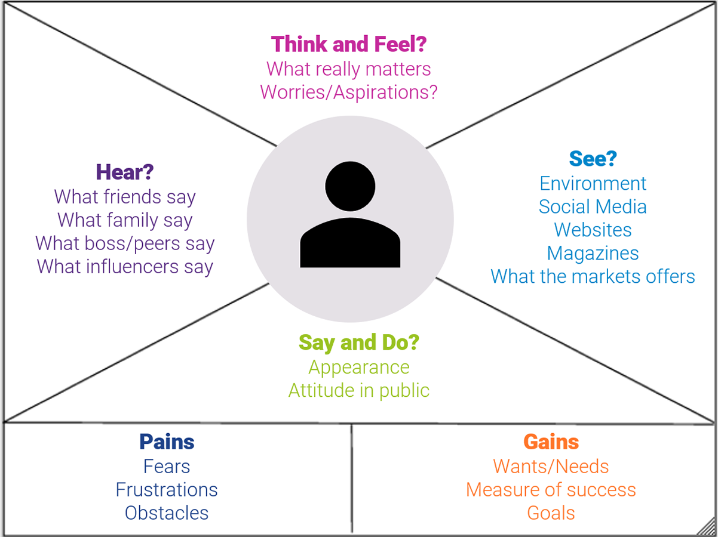

Reference: https://www.mural.co/templates/empathy-map-canvas
Example: LearnHub
This empathy map illustrates the thoughts, feelings, behaviors, and expressions of a healthconscious persona. It provides a structured understanding of user concerns related to fitness and healthy eating.
Says:
“It’s too hard to find healthy options when eating out.”
Thinks:
“Am I exercising enough compared to my peers?”
Does:
Uses a fitness tracker daily.
Feels:
Frustrated with my lack of progress.

